Experiment 5: Solving the 8-Queens Problem Using Backtracking
AIM: To find the collision-free placement of components on a grid.
QUESTION:
An automated placement system must position eight components on an 8 × 8 grid such that no two components interfere with one another. Model this as the 8-Queens problem, where each queen represents a component and can attack another queen along the same row, column, or diagonal.
Develop a Python program using the backtracking algorithm to find a valid arrangement of eight queens on the chessboard.
The program must:
- Represent the chessboard as an 8 × 8 grid and track the positions of the queens.
- Place one queen at a time while ensuring that no two queens share the same row, column, or diagonal.
- Use recursive backtracking to undo an invalid placement and explore alternative positions.
- Display the final chessboard arrangement and the positions of all eight queens.
- Report the number of placement attempts and explain how constraint checking and backtracking help find a valid solution.
CODE:
N = 8
board = [-1] * N
attempts = 0
def is_safe(row, col):
for prev_row in range(row):
prev_col = board[prev_row]
if prev_col == col:
return False
if abs(prev_row - row) == abs(prev_col - col):
return False
return True
def solve(row):
global attempts
if row == N:
return True
for col in range(N):
attempts += 1
if is_safe(row, col):
board[row] = col
if solve(row + 1):
return True
board[row] = -1
return False
if solve(0):
print("Solution Found:")
for row in range(N):
for col in range(N):
if board[row] == col:
print("Q", end=" ")
else:
print(".", end=" ")
print()
print("\nQueen Positions:")
for row, col in enumerate(board):
print(f"({row+1}, {col+1})")
print("Placement Attempts:", attempts)
else:
print("No Solution Found")

Output:

Q . . . . . . .
. . . . Q . . .
. . . . . . . Q
. . . . . Q . .
. . Q . . . . .
. . . . . . Q .
. Q . . . . . .
. . . Q . . . .

Queen Positions:
(1, 1)
(2, 5)
(3, 8)
(4, 6)
(5, 3)
(6, 7)
(7, 2)
(8, 4)

Placement Attempts: 876

Experiment 6: Solving the Map Colouring Problem Using CSP
AIM: To make frequency allocation for neighbouring cellular network regions.
QUESTION:
A telecommunications network is divided into interconnected regions. To reduce interference, neighbouring regions must be assigned different frequency bands. Model the network as a Constraint Satisfaction Problem (CSP), where each region is a variable, the available frequency bands form its domain, and neighbouring regions must receive different assignments.
Develop a Python program to solve the map-colouring problem using CSP techniques.
The program must:
- Represent each region as a variable and define its available colours as a domain.
- Specify adjacency constraints requiring neighbouring regions to have different colours.
- Use backtracking search to find a valid colour assignment.
- Display the final map-colouring assignment and verify that all adjacency constraints are satisfied.
- Report the number of assignments attempted and explain how CSP variables, domains, and constraints guide the search.
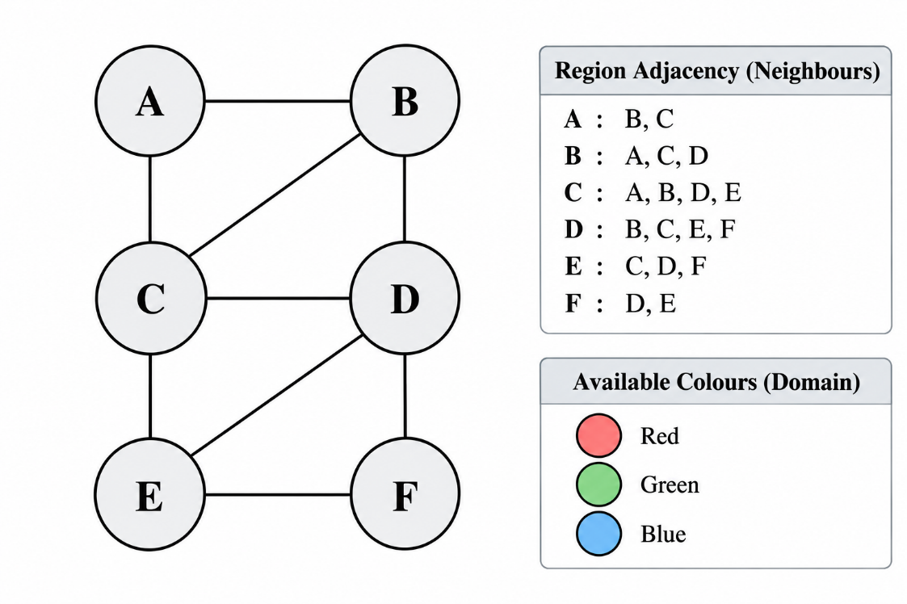

CODE:
regions = {
"A": ["B", "C"],
"B": ["A", "C", "D"],
"C": ["A", "B", "D", "E"],
"D": ["B", "C", "E", "F"],
"E": ["C", "D", "F"],
"F": ["D", "E"]
}

colors = ["Red", "Green", "Blue"]
assignment = {}
attempts = 0

def is_consistent(region, color):
for neighbour in regions[region]:
if assignment.get(neighbour) == color:
return False
return True

def backtrack(index):
global attempts

region_list = list(regions.keys())

if index == len(region_list):
return True

region = region_list[index]

for color in colors:
attempts += 1

if is_consistent(region, color):
assignment[region] = color

if backtrack(index + 1):
return True

del assignment[region]

return False

if backtrack(0):
print("Valid Map Colouring Assignment:")

for region in regions:
print(region, "=", assignment[region])

valid = True

for region in regions:
for neighbour in regions[region]:
if assignment[region] == assignment[neighbour]:
valid = False

print("All Adjacency Constraints Satisfied:", valid)
print("Assignments Attempted:", attempts)

else:
print("No Valid Colouring Found")

Output:
Valid Map Colouring Assignment:
A = Red
B = Green
C = Blue
D = Red
E = Green
F = Blue

All Adjacency Constraints Satisfied: True
Assignments Attempted: 12

Experiment 7 - Implementing the Minimax Algorithm
AIM: To demonstrate decision-making in a two-player strategy game.
QUESTION:
A game-playing AI must select its best move in a two-player game where one player tries to maximize the score while the opponent tries to minimize it.
Develop a Python program to implement the Minimax algorithm for a game represented as a binary game tree. The program must:
- Represent the game tree with terminal utility values.
- Treat the AI as the maximizing player and the opponent as the minimizing player.
- Recursively evaluate the game tree using the Minimax algorithm.
- Display the evaluated values and the best move selected by the AI.
- Explain how the algorithm assumes that both players choose optimal moves.

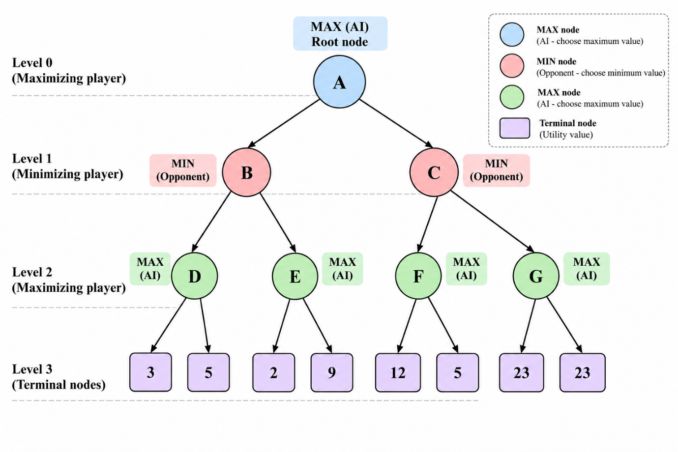

CODE:
# Minimax Algorithm

game_tree = {
"B": {
"D": [3, 5],
"E": [2, 9]
},
"C": {
"F": [12, 5],
"G": [23, 23]
}
}
def minimax(node, maximizing):

if isinstance(node, list):
if maximizing:
return max(node)
else:
return min(node)

values = []

for child in node.values():
value = minimax(child, not maximizing)
values.append(value)

if maximizing:
return max(values)
else:
return min(values)

print("Minimax Evaluation:")

move_values = {}

for move, subtree in game_tree.items():
move_values[move] = minimax(subtree, False)

print("Root Move Values:", move_values)

best_move = max(move_values, key=move_values.get)

print("Best Move for AI:", best_move)
print("Best Utility Value:", move_values[best_move])

OUTPUT:
Minimax Evaluation:
Root Move Values: {'B': 5, 'C': 12}

Best Move for AI: C
Best Utility Value: 12

Experiment 8 - Implementing Alpha-Beta Pruning
AIM: To optimize decision-making in a two-player strategy game.
QUESTION:
A chess-playing AI evaluates possible moves by exploring a game tree. Since evaluating every possible move is computationally expensive, the AI uses Alpha-Beta Pruning to eliminate branches that cannot influence the final decision.
Develop a Python program to implement the Alpha-Beta Pruning algorithm for a chess-inspired game tree with multiple possible moves and terminal utility values.
The program must:
- Represent the game tree with multiple candidate moves and terminal utility values.
- Implement Alpha-Beta Pruning using alpha and beta bounds.
- Identify and skip branches that cannot affect the final decision.
- Display the selected move, its utility value, the number of nodes evaluated, and the number of branches pruned.
- Explain how Alpha-Beta Pruning reduces the search effort while preserving the optimal decision.

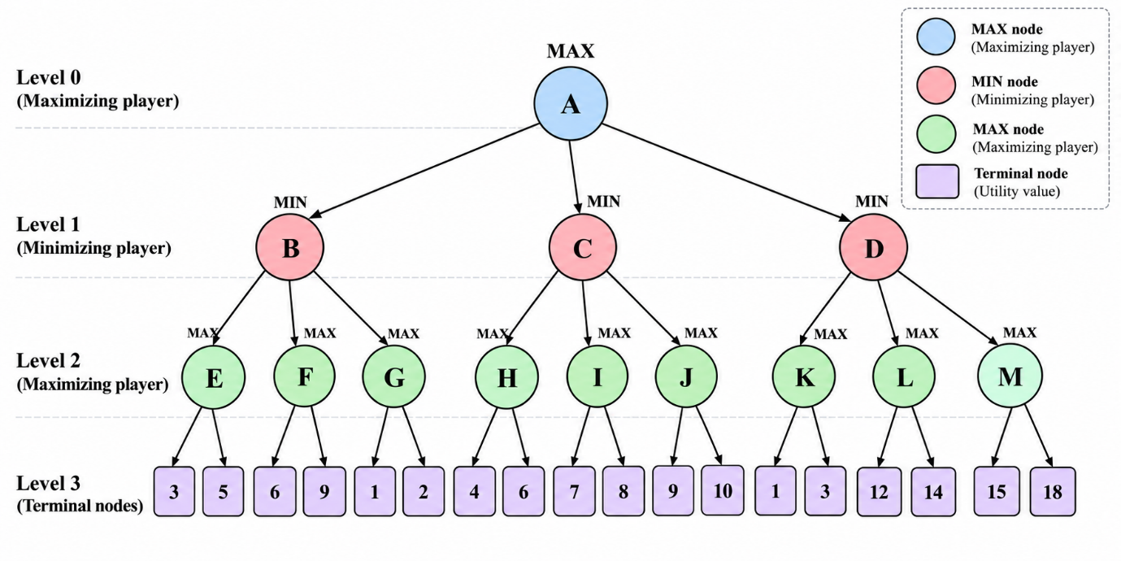

CODE:
# Alpha-Beta Pruning Algorithm

game_tree = {
"B": {
"E": [3, 5],
"F": [6, 9],
"G": [1, 2]
},

"C": {
"H": [4, 6],
"I": [7, 8],
"J": [9, 10]
},

"D": {
"K": [1, 3],
"L": [12, 14],
"M": [15, 18]
}
}

evaluated = 0
pruned = 0

def count_nodes(node):
if isinstance(node, (int, float)):
return 1

children = list(node.values()) if isinstance(node, dict) else node

return sum(count_nodes(x) for x in children)

def alpha_beta(node, maximizing, alpha, beta):
global evaluated, pruned

if isinstance(node, (int, float)):
evaluated += 1
return node

children = list(node.values()) if isinstance(node, dict) else node

if maximizing:
value = float('-inf')
else:
value = float('inf')

for i, child in enumerate(children):

child_value = alpha_beta(
child, not maximizing, alpha, beta
)

if maximizing:
value = max(value, child_value)
alpha = max(alpha, value)

else:
value = min(value, child_value)
beta = min(beta, value)

if alpha >= beta:
for remaining in children[i+1:]:
pruned += count_nodes(remaining)
break

return value

move_values = {}

alpha = float('-inf')
beta = float('inf')

for move, subtree in game_tree.items():

move_values[move] = alpha_beta(
subtree, False, alpha, beta
)

alpha = max(alpha, move_values[move])

best_move = max(move_values, key=move_values.get)

print("Root Move Values:", move_values)
print("Best Move for AI:", best_move)
print("Best Utility Value:", move_values[best_move])
print("Terminal Nodes Evaluated:", evaluated)
print("Terminal Nodes Pruned:", pruned)

OUTPUT:
Root Move Values: {'B': 2, 'C': 6, 'D': 3}

Best Move for AI: C
Best Utility Value: 6

Terminal Nodes Evaluated: 11
Terminal Nodes Pruned: 7

